Terrestrial Biomes
Name | Location | Climate | Environmental Factors | Plants/  Adaptations | Animals/  Adaptations
Deciduous
Forest

Temperate
Rain Forest

Tropical
Rain Forest

Taiga/
Boreal Forest

Grassland

Chapparal

Desert

Tundra

Vertical Zonation of Biomes
Climbing in elevation causes a much more rapid change in climate than moving the same distance toward the poles:
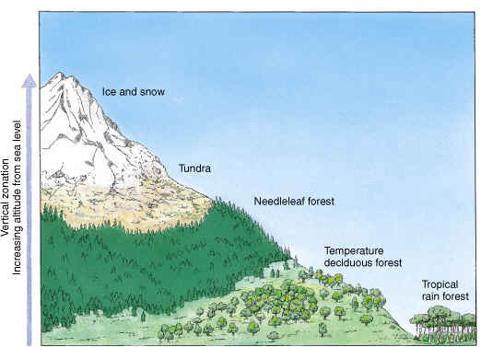
Notice the type of forest shown at the base of the mountain in the diagram.
Identify one geographical location that displays the vertical zonation shown in the diagram:

Briefly discuss the biogeographical features of the location you have identified using specific information from your research.

