APES Study Guide
Air Pollution and Global Atmospheric Issues

Vocabulary:
It is necessary that you know the meaning of the following terms in order to answer application and evaluation questions on your upcoming assessment. You may write out the definition, make notecards (handwritten or digital), use the online vocabulary resources or simply review the terms in your notes. It is YOUR responsibility to ensure that you know these terms!
Asbestos Urban heat island Stratosphere
Radon Sick building syndrome Thermal expansion
Methane Clean Air Act Kyoto protocol
Photochemical smog Greenhouse effect Montreal protocol
Industrial smog Troposphere

Short Answer:
You are REQUIRED to answer each of the following questions on separate paper. ALWAYS write in complete sentences. Use both your class notes AND your textbook for reference.
- Explain the phrase “Good up high, Bad nearby” as it relates to ozone.
- What is the major source of radon in human homes? What is the major health concern related to radon accumulation?
- Explain why industry, transportation and energy production are the major sources of anthropogenic (human-caused) sources of gaseous air pollutants in the US.
- Explain how a thermal inversion (temperature inversion) worsens air pollution at ground level.
- Name 3 reasons that air pollution is a greater health threat to children than adults.
- Which air pollutants are associated with the formation of acid rain? How does acid deposition lead to forest decline?
- Explain this graph:
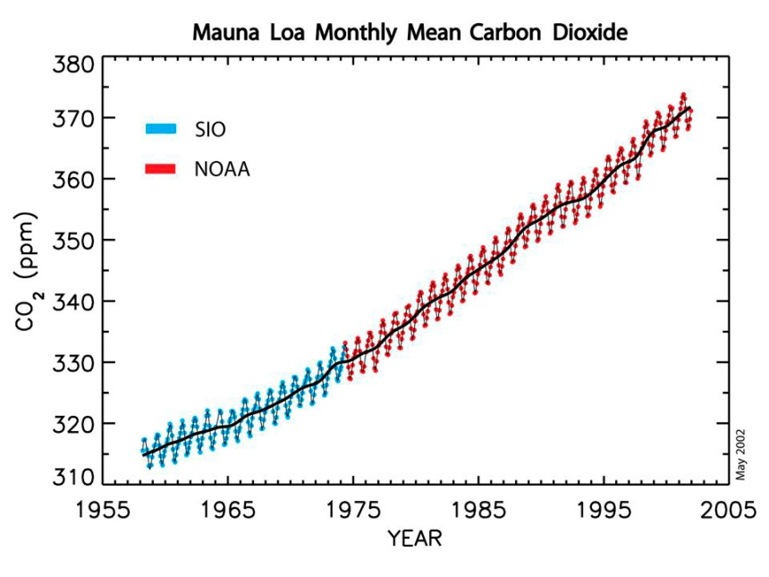

- The combustion of one gallon of gasoline produces about 5 pounds of carbon dioxide. Two autos are making a round trip of 300 miles. The first auto gets 10 miles/gallon and the second auto gets 20 miles/gallon. Approximately how much LESS carbon dioxide will be produced by the second auto? SHOW YOUR WORK.
- HOW might global climate change lead to increase in insect borne diseases?
- Explain HOW CFC’s cause the destruction of ozone molecules.

*Make sure you study your “Criteria Pollutants” chart/booklet/foldable*

APES Study Guide
Air Pollution and Global Atmospheric Issues

Vocabulary:
It is necessary that you know the meaning of the following terms in order to answer application and evaluation questions on your upcoming assessment. You may write out the definition, make notecards (handwritten or digital), use the online vocabulary resources or simply review the terms in your notes. It is YOUR responsibility to ensure that you know these terms!
Asbestos Urban heat island Stratosphere
Radon Sick building syndrome Thermal expansion
Methane Clean Air Act Kyoto protocol
Photochemical smog Greenhouse effect Montreal protocol
Industrial smog Troposphere

Short Answer:
You are REQUIRED to answer each of the following questions on separate paper. ALWAYS write in complete sentences. Use both your class notes AND your textbook for reference.
- Explain the phrase “Good up high, Bad nearby” as it relates to ozone.
- What is the major source of radon in human homes? What is the major health concern related to radon accumulation?
- Explain why industry, transportation and energy production are the major sources of anthropogenic (human-caused) sources of gaseous air pollutants in the US.
- Explain how a thermal inversion (temperature inversion) worsens air pollution at ground level.
- Name 3 reasons that air pollution is a greater health threat to children than adults.
- Which air pollutants are associated with the formation of acid rain? How does acid deposition lead to forest decline?
- Explain this graph:

- The combustion of one gallon of gasoline produces about 5 pounds of carbon dioxide. Two autos are making a round trip of 300 miles. The first auto gets 10 miles/gallon and the second auto gets 20 miles/gallon. Approximately how much LESS carbon dioxide will be produced by the second auto? SHOW YOUR WORK.
- HOW might global climate change lead to increase in insect borne diseases?
- Explain HOW CFC’s cause the destruction of ozone molecules.

*Make sure you study your “Criteria Pollutants” chart/booklet/foldable*

