**PLANTS (Fast and Furious!)**

**Plant Classification:**

1. _______________________ _______________

(no tubes/vessels) (example)

_______________________

1. _______________________ (use spores for reproduction)

(tubes/vessels for transport) _____________________ _______________

________________________ (seeds in cones) (example)

(use seeds for reproduction)

_____________________ _______________

(flowering plants–seeds in fruit) (example)

**STERNGRR Processes**

|  |  |
| --- | --- |
| **S**ynthesis |  |
| **T**ransport | Non-vascular:  Vascular: |
| **E**xcretion |  |
| **R**espiration |  |
| **N**utrition |  |
| **G**rowth and Development |  |
| **R**eproduction | Asexual:  Spores:  Seeds:   * Found in cones in ________________________ * Found in fruits that develop from flowers in ____________________   Flowers:   * Male parts: * Female parts: * Pollination occurs when ____________________________________ * Fertilization occurs when ___________________________________ |
| **R**egulation | Hormones:  Tropisms: |

Common Characteristics:

1.

2.

3.

FLOWER CROSS-SECTION

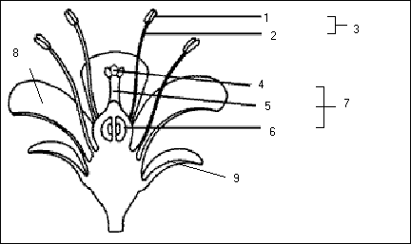

LEAF CROSS-SECTION