The Sky Isn’t Falling….but There’s a Hole Up There!
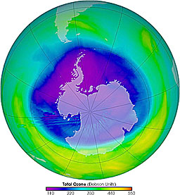
Pre-Activity Questions:
Read the information provided and answer the following questions.
- Describe the formation of stratospheric ozone.
- Draw a picture that illustrates the destruction of stratospheric ozone by CFC’s.
- How do ice crystals impact the destruction of ozone?
- How many DU’s (Dobson Units) constitute a hole?
- Describe the precautions you would need to take if the UV index = 5.0.

Procedure:
Examine the two South Polar Total Ozone Monthly Mean plots showing the levels of ozone for October during two different years. Trace around the areas where the ozone level is at or below 225 DU’s in October 1980. Use the graph paper to determine the number of squares occupied by the “hole”. Repeat this procedure for October 1989.

Data:
 | 1980 | 1989
# squares in plot

# of squares of ozone < 225 DU

Size of “hole” (% of plot)

Calculate the % change in the 9 year period by using the following equation:
new – old 1989 % - 1980 %
% change =
old 1980 %

Analysis:
- During which year was the ozone hole larger?
- Explain WHY ozone depletion is occurring.
- Calculate the rate of change for this period of time.
- Do scientists predict that the ozone hole will continue to increase in size? Why or why not?
- List three consequences of depleted ozone levels in the atmosphere.

