C:\Documents and Settings\shari.mudd\Local Settings\Temporary Internet Files\Content.IE5\471MJY3N\MC900226512[1].wmf

**ORGANIC**

**“The Core Four”**

C:\Documents and Settings\shari.mudd\Local Settings\Temporary Internet Files\Content.IE5\471MJY3N\MC900226512[1].wmf

Carbohydrates Lipids Nucleic Acids Proteins

|  |  |  |  |  |
| --- | --- | --- | --- | --- |
| Elements |  |  |  |  |
| Monomer/Subunit |  |  |  |  |
| Functions |  |  |  |  |
| Examples |  |  |  | ENZYMES |

**INORGANIC**

Examples:

1.

2.

3. Acids / Bases

Buffers!

Lock and Key!

Enzyme-Mediated Pathway:

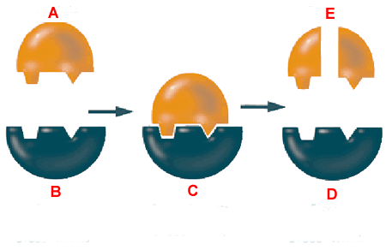

Catalysts -

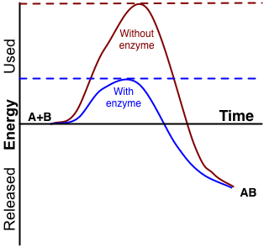

STERNGRR?

Enzymes are:

Enzymes are: