Environmental Health and Toxicology: Chapter 14 Reading Guide
- Read and summarize the case study on BPA (How used / Cause for concern / Regulation).

- Identify the four types of environmental hazards and give an example of each.
Hazard | Example

- SUPPORT the following statement: “Infectious disease is a greater threat to human health than is non-infectious disease and injury”.

- Explain why pathogenic agents are able to spread so quickly today. Give an example.

- Identify 2 ways that environmental changes are impacting the spread of disease.
a.

b.

- Explain the meaning of the statement “The dose makes the poison”.

- Differentiate between natural and synthetic chemicals. Give examples of each.
SYNTHETIC =
NATURAL =

- Who was Rachel Carson? How was she important to the study of toxicology?
- Identify the impact on human health for each of the following toxicants:
Toxicant | Impact on Human Health
Carcinogen
Mutagen
Teratogen
Neurotoxin
Allergen
Endocrine disruptor

- Compare and contrast pesticide movement in water and air:
Water Both Air
- Annotate the diagram to explain the processes of “bioaccumulation” and “biomagnification”.
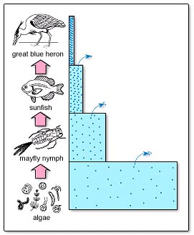

- Identify 2 methods used to study the effects of hazards on wildlife and 3 methods used to study the effects of hazards in humans.
Studying the Effects of Hazards
On Wildlife | On Humans
xxxxxxxxxxxxxxxxxxxxxxxxxxxxxxxxxxxxxxxxx

- Answer the questions about the diagram below:
What is the name for this type of graph? ___________________
_________________________
At what dosage is the “threshold” of toxicity? __________________________
At what dosage is the LD₅₀? __________________________

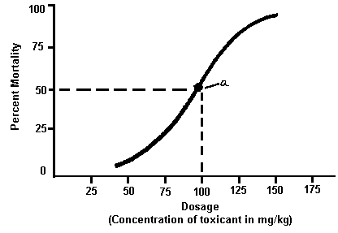
- Identify some situations in which determining the LD₅₀ or ED₅₀ of a toxicant can be beneficial.

- Explain the concept of “synergy”.

- Name the steps involved in risk assessment:
i)

ii)

- Explain the 2 approaches that are used in determining safety of chemical substances:
i)

ii)

- Complete the chart summarizing policy regarding hazardous substances:
Policy | Where | What it says
Toxic Substances Control Act
REACH
Stockholm Convention on POPs

