Energy Flow in an Ecosystem
(adapted from Biozone Environmental Science Modular Workbook)

The Laws of Thermodynamics state:
- Energy cannot be created or destroyed but can be converted to another form, and
- As energy conversions occur, some usable energy is “lost” as heat
Therefore, energy stored in the biomass at each trophic level in an ecosystem can be transferred to another trophic level, with some being “lost” as heat energy to the environment. The percentage of energy transferred from one trophic level to the next varies between 5-20% and is called the ecological efficiency. The 10% rule of energy transfer is often used. In order to understand energy flow, one must also understand the idea of ecosystem productivity.
- Gross Primary Productivity (GPP) – total organic material produced by plants, including that lost as heat due to respiration
- Net Primary Productivity (NPP) – the amount of biomass that is available to consumers at subsequent trophic levels after accounting for that lost as heat

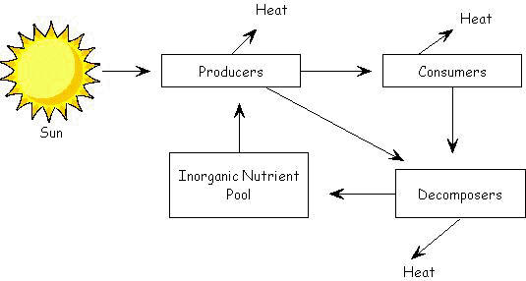
Units are in kJ/m²

?
22,950
50,450
87,400
1,700,000
D
D
D
C
C
B
A
http://mrskingsbioweb.com/images/imageT5K.jpg

Study the diagram of energy transfer in an ecosystem shown above to answer the questions on the next page.

- What is the original form of energy that powers this ecosystem? _______________________

- Identify the process that is occurring at each labeled point on the diagram.
- ________________________________________
- ________________________________________
- ________________________________________
- ________________________________________

- Not all solar energy emitted is absorbed by plants. If 7,000,000 kJ/m² of sunlight falls on plant surfaces and only 1,700,000 kJ/m² is absorbed by plants, calculate the percentage of light energy that is absorbed by the plants. ________________%
Work:

- What happens to the light (solar) energy that is not absorbed by the plants? ______________ ____________________________________________________________________________

- Given that the sum of energy input always equals the sum of energy output calculate the missing value on the diagram. ________________ kJ/m²
Work:

- Calculate the percentage of light energy absorbed that is actually converted (fixed) into producer energy. ___________________ kJ/m²
Work:

- What happens to the energy that is absorbed by the plants but is not “fixed”? _____________ ____________________________________________________________________________

- Calculate the percentage of energy that is passed from the producers to the consumers. ___________________ kJ/m²
Work:

- According to the diagram, what is the Gross Primary Productivity for this ecosystem? ___________________ kJ/m²

- Using the values on the diagram, calculate the Net Primary Productivity for this ecosystem. ___________________ kJ/m²
Work:

