**Ecology: _________________________________________________________________________**

**Population Growth:**

J-curve



S-curve



Limiting factors

* Density dependent
* Density Independent

**Succession:**

**Transfer of ENERGY:**

Ultimate source of energy ___________________

Moves through ____________ _______________

LEAST

energy

MOST

energy

10% rule: ________________________________

Where is the “lost” energy? __________________

_________________________________________

**Organization of the Biosphere:** 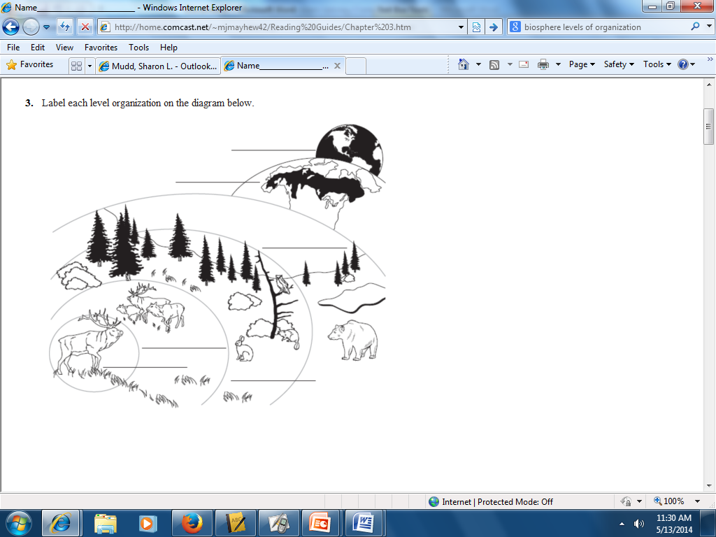

Biotic factors ________________________________

Abiotic factors _______________________________

**Cycling of MATTER:**

Decomposers_____________________________

________________________________________

Biogeochemical cycles

|  |  |
| --- | --- |
| Water cycle |  |
| Carbon cycle |  |
| Nitrogen cycle |  |

Every organism has a specific “**NICHE**”:

**Community Interactions**

**Symbiosis**








**Predation**

**Competition**