**DNA and Heredity**

Where is your DNA?

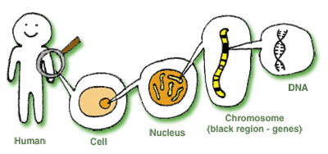

**D ___________________ N___________A_________**

DNA controls HEREDITY



DNA is one of the ______________

|  |  |
| --- | --- |
| **DNA Structure:**  http://ircamera.as.arizona.edu/NatSci102/NatSci102/images/dna2.gif | **DNA Replication:**  Cell , 5 Animation on Dna Replication : Simple Dna Replication Animation |

DNA is different in different organisms because….

**Process of Protein Synthesis:**

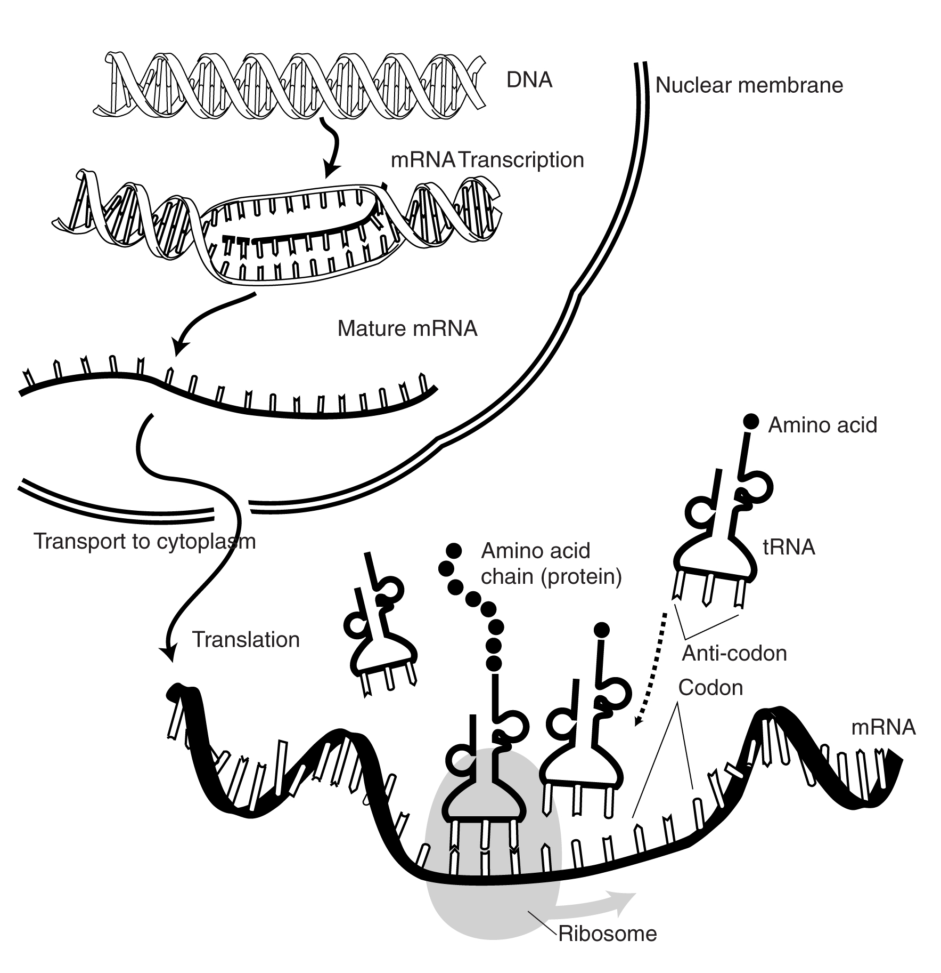

DNA is used as a CODE for

________________ _________________

One ___________, one ______________

Gene:

DNA: _TAC TCA CGT GTC ACT

RNA (codons): __________________________

Amino acids: __________________________

(use codon chart)

3 Types of RNA:

**m**RNA

**t**RNA

**r**RNA

Mutations:

* Point mutation
* Frameshift mutation