Cultural Eutrophication

Bodies of water that have minimal levels of plant nutrients are said to be unenriched and are categorized as “oligotrophic”. An oligotrophic lake is typically deep, has clear water, and supports only small populations of aquatic organisms. As a lake is enriched by inorganic plant nutrients, increased algal growth occurs causing it to appear cloudy. This nutrient enrichment is termed “eutrophication”. Eutrophic lakes support larger populations of aquatic organisms, although different species than those present in oligotrophic lakes.

Identify each description with an “O” for oligotrophic, or “E” for eutrophic.
_____ Deep, clear water _____ Large populations of aquatic life
_____ Cloudy water _____ Small populations of aquatic life
_____ More photosynthetic activity _____ May have algal blooms
_____ Input of nitrogen and phosphorus _____ More aesthetically pleasing

Over time, enrichment of surface waters occurs naturally. However, high inputs of inorganic plant nutrients can lead to an undesirable situation known as “cultural eutrophication”. In this case, eutrophication is accelerated by human caused inputs of inorganic plant nutrients from a variety of sources.

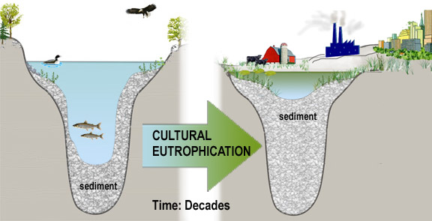

Identify one source of inorganic plant nutrients caused by humans _________________
Identify one source of organic pollution that contains plant nutrients________________

The excessive algal growth that characterizes a eutrophic lake disrupts the natural balance of producers and consumers in the ecosystem. An “algal bloom”, or excessive growth of algae, cannot be supported by the lake environment. As the death of these algae occurs, their bodies must be decomposed.
Biological Oxygen Demand
Biological Oxygen Demand (BOD) is the amount of oxygen needed by microorganisms to decompose organic wastes into carbon dioxide, water, and minerals. A large amount of organic waste in the water generates a high BOD which depletes the water of dissolved oxygen (DO). A lowered DO content impacts not only the physical quality of the water, but also limits the aquatic organisms that can thrive.

Explain how cultural eutrophication by nutrient enrichment can lead to a high BOD.

Identify two additional types of organic wastes that can result in a high BOD.
1.
2.

As the biological oxygen demand increases, microorganisms work to decompose the organic wastes. Since decomposition is a form of cellular respiration, oxygen is used in the process, thereby decreasing the dissolved oxygen content of the water. In a stream environment, an “oxygen sag” curve often results from the input of organic wastes as decomposers rid the water of the wastes as the water moves downstream of the initial input.
Use the diagram to answer the following questions:
- As BOD increases, DO ______________.
- In which zone is the DO content lowest? ___________________
- What types of organisms are found in the recovery zone? ___________________
- Does the stream environment ever return to normal? Explain. _____________________________________________
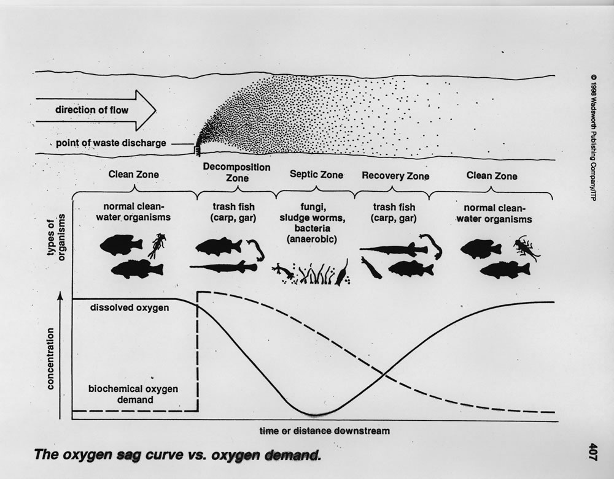

Summary:
Use the word bank below to complete the concept map.

Oxygen sag Algal bloom Fertilizers
Sewage DO Inorganic plant nutrients
Nutrient enrichment BOD Decomposed

Eutrophication
also called

caused by leads to

from must be

must be

causes increased

depletes

may cause

